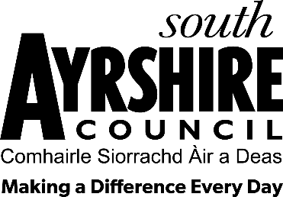

LOCAL GOVERNMENT (SCOTLAND) ACT 1973

SOUTH AYRSHIRE COUNCIL

COMMUNITY COUNCIL BY-ELECTIONS 2025

A poll is to be held for Community Council members to serve on the
Community Council.

Name of Community Council | Number of  Vacancies
Symington | 2

Nomination Forms may be obtained by contacting:

Returning Officer

Community Council Elections

County Buildings
Wellington Square
Ayr KA7 1DR

Telephone: 01292 612305

E-mail: communitycouncils@south-ayrshire.gov.uk

Latest time for the delivery of nomination papers is: Friday 14th February 2025 by 4 pm

Completed nomination forms can be sent to the above email address or returned in the envelope provided to the above address.

Jamie Tait
Returning Officer

